ASSIGNMENT-11.1

2303A51852
Task Description #1 – Stack Implementation
Task: Use AI to generate a Stack class with push, pop, peek, and is_empty methods.
Sample Input Code:
class Stack:
pass
Expected Output:
- A functional stack implementation with all required methods and docstrings.
PROMPT: Genrate the a stack class with this operations push,pop,peek,and is_empty in python
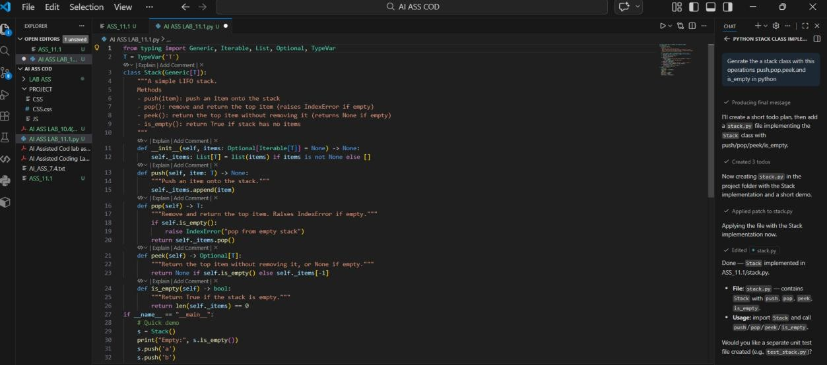
OUTPUT:
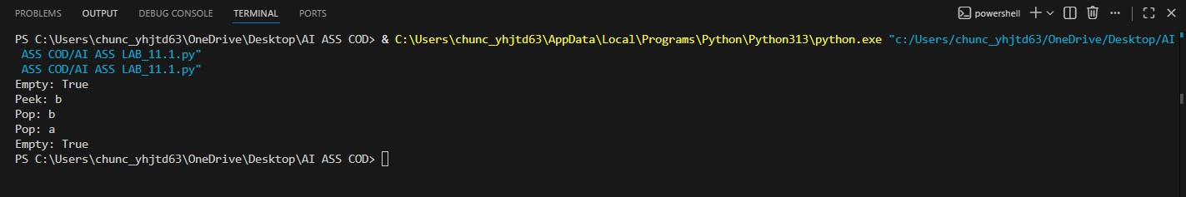
Task Description #2 – Queue Implementation
Task: Use AI to implement a Queue using Python lists. Sample Input Code:
class Queue:

PROMPT: Generate queue using python list and perform its operations
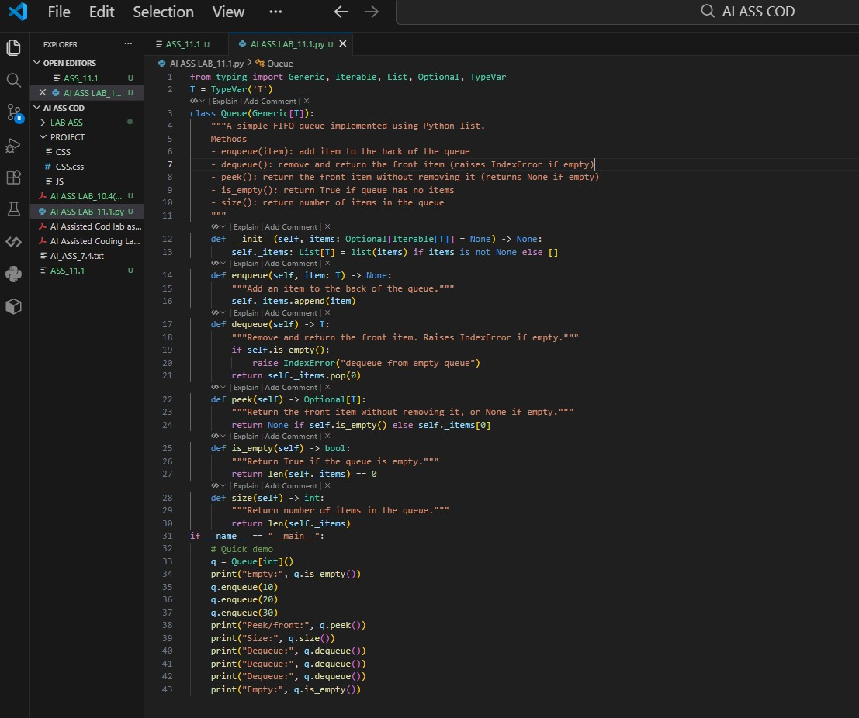

OUTPUT:
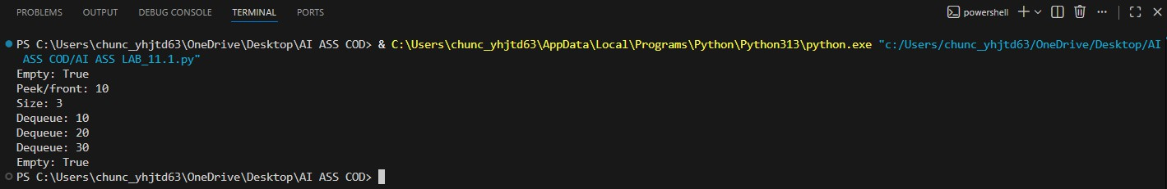
Task Description #3 – Linked List
Task: Use AI to generate a Singly Linked List with insert and display methods.
Sample Input Code: class Node:
pass
class LinkedList: pass

PROMPT: Generate the singly linked list with insert and display methods
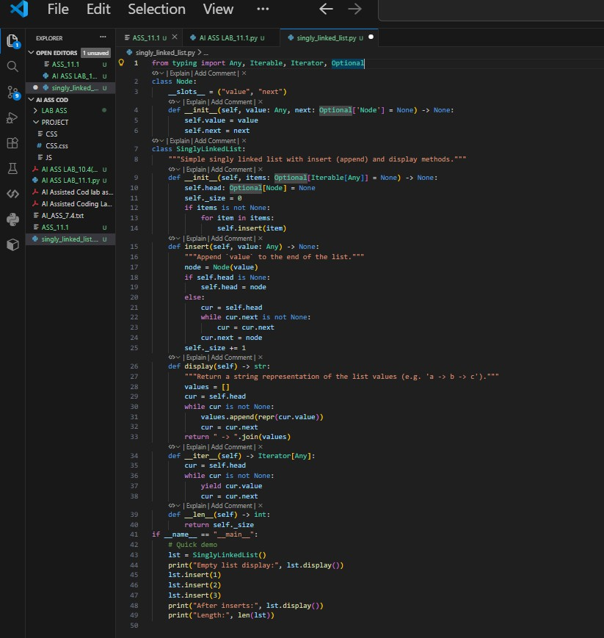
OUTPUT:

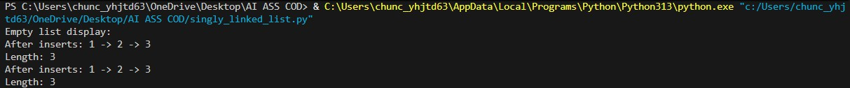
Task Description #4 – Binary Search Tree (BST)
Task: Use AI to create a BST with insert and in-order traversal methods.
PROMPT: Generate the Binary search tree with insert and traverse in-order method

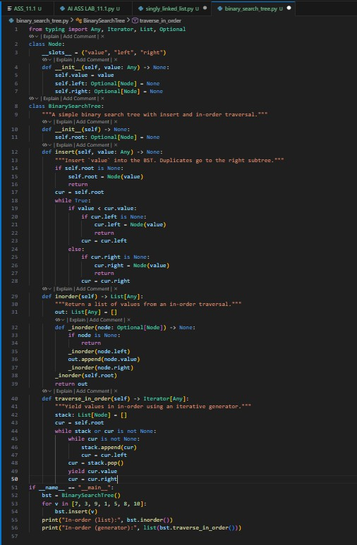
OUTPUT:

Task Description #5 – Hash Table

Task: Use AI to implement a hash table with basic insert, search, and delete methods.
PROMPT: Generate Hash table with basic insert, search and delete methods
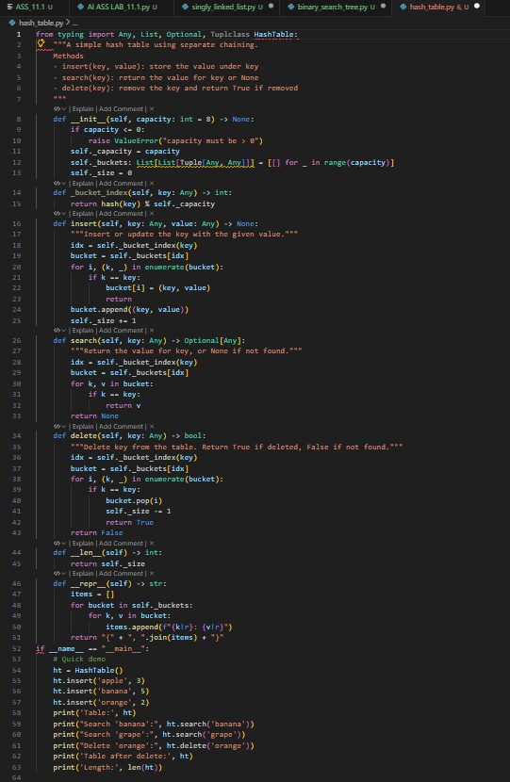

OUTPUT:
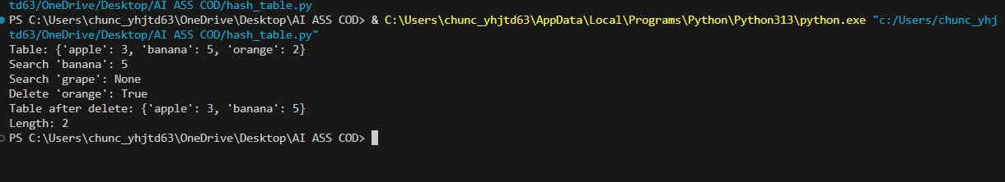
Task Description #6 – Graph Representation
Task: Use AI to implement a graph using an adjacency list. PROMPT: Generate a graph using an adjacency list

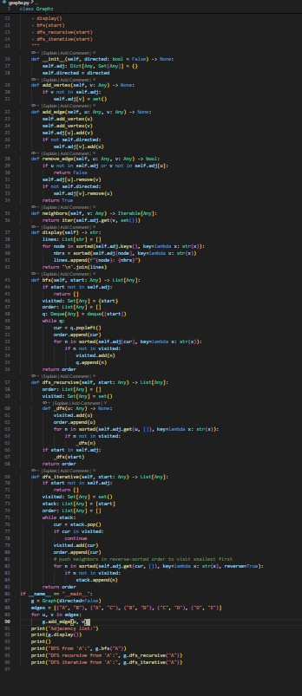

OUTPUT:

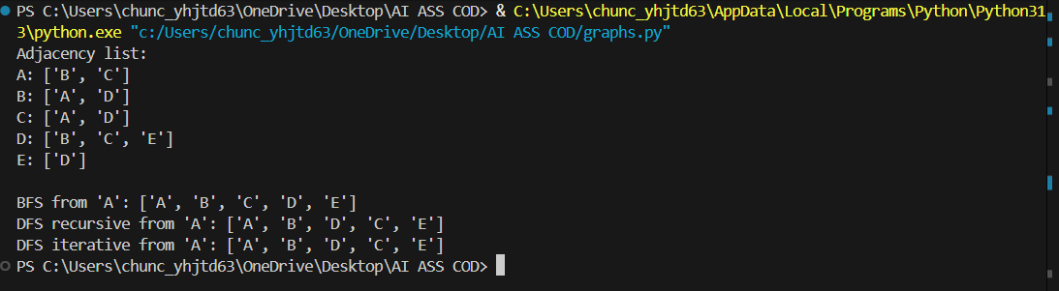
Task Description #7 – Priority Queue
Task: Use AI to implement a priority queue using Python’s heapq PROMPT: Generate priority Queue using py module.
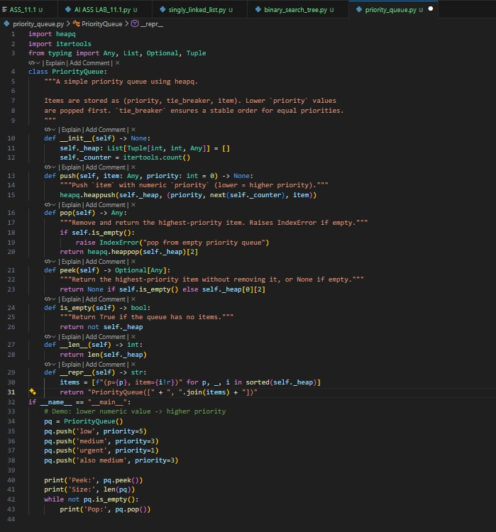

OUTPUT:

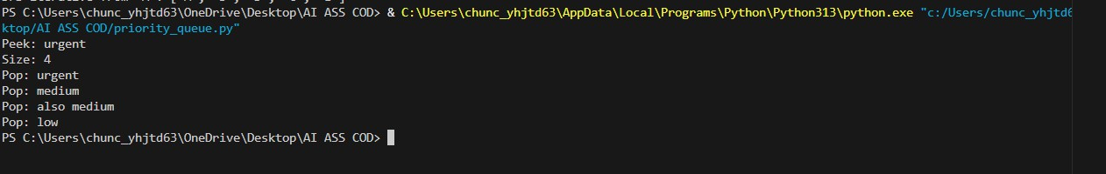
Task Description #8 – Deque
Task: Use AI to implement a double-ended queue using collections.deque.
PROMPT: Generate a double-ended queue in deque

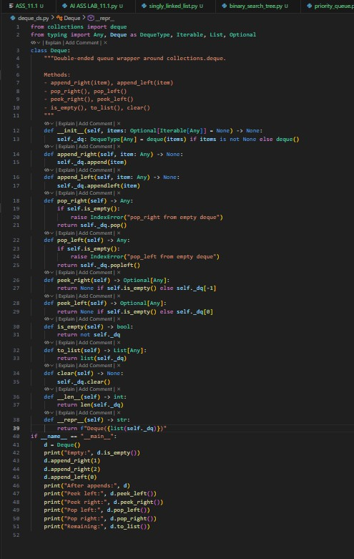

OUTPUT:
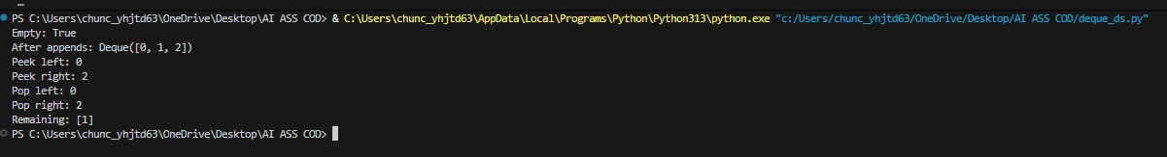

Task Description #9 Real-Time Application Challenge – Choose the Right Data Structure
Scenario:
Your college wants to develop a Campus Resource Management System that handles:
- Student Attendance Tracking – Daily log of students entering/exiting the campus.
- Event Registration System – Manage participants in events with quick search and removal.
- Library Book Borrowing – Keep track of available books and their due dates.
- Bus Scheduling System – Maintain bus routes and stop connections.
- Cafeteria Order Queue – Serve students in the order they arrive. Student Task:
  - For each feature, select the most appropriate data structure from the list below:
- Stack
- Queue
- Priority Queue
- Linked List
- Binary Search Tree (BST)
- Graph
- Hash Table
- Deque
  - Justify your choice in 2–3 sentences per feature.
  - Implement one selected feature as a working Python program with AI-assisted code generation

PROMPT:USING ABOVE GENERATE ONE CODE FOR IMPLEMENT

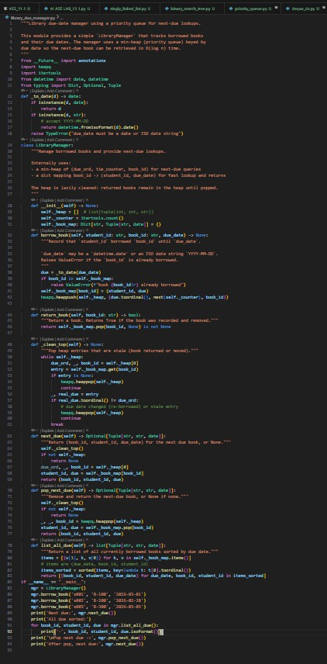
Output:

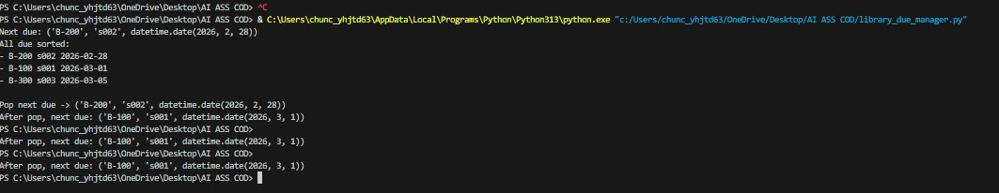
Task Description #10: Smart E-Commerce Platform – Data Structure Challenge
An e-commerce company wants to build a Smart Online Shopping System with:
- Shopping Cart Management – Add and remove products dynamically.
- Order Processing System – Orders processed in the order they are placed.
- Top-Selling Products Tracker – Products ranked by sales count.
- Product Search Engine – Fast lookup of products using product ID.
- Delivery Route Planning – Connect warehouses and delivery locations.
PROMPT: Select suitable data structures for the given Smart E-Commerce features and justify your choices in 2–3 sentences. Then implement any one feature as a Python program with comments and docstrings.

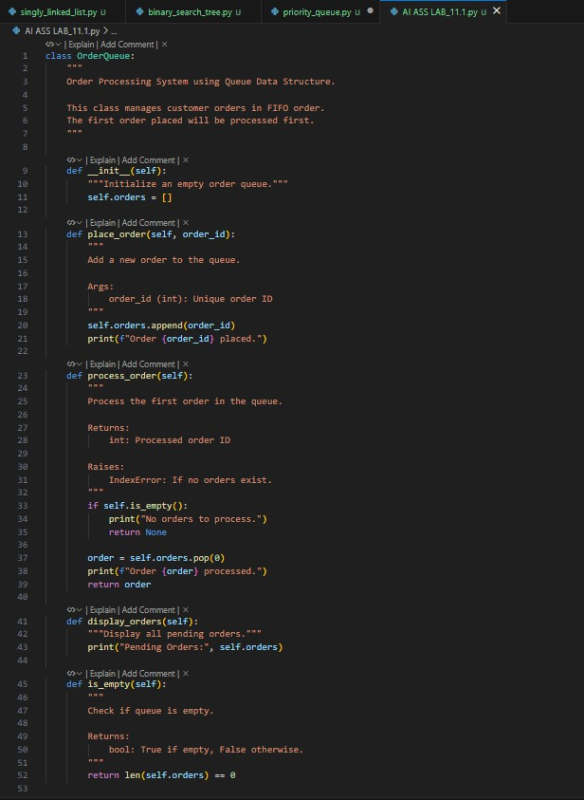
OUTPUT:

